Akimal

Submitted in partial fulfilment of the requirements

of the degree of

Bachelor of Engineering in

Artificial Intelligence and Data Science

by

Student Name(s)

**Madhusudhana Naidu**

**Manav Pahilwani**

**Om Gaydhane**

**Akshat Tiwari**

under the guidance of

Supervisor (s):

**Dr. M. Vijayalakshmi**

**Mr. Ajinkya Valanjoo**



**Department of Artificial Intelligence and Data Science**

**Vivekanand Education Society’s Institute of Technology**

**2021-2022**

**Department of Artificial Intelligence and Data Science**

**CERTIFICATE**

This is to certify that ***Madhusudhana Naidu, Om Gaydhane, Manav Pahilwani, Akshat Tiwari*** of Second Year of Artificial Intelligence and Data Science studying under the University of Mumbai have satisfactorily presented the Mini Project entitled **Akimal** as a part of the MINI-PROJECT for Semester-III under the guidance of **Dr. M. Vijayalakshmi** & **Mr. Ajinkya Valanjoo** in the year 2021-2022.

Date: 18-12-2021

(Name and sign) (Name and sign)

Head of Department Supervisor/Guide

**Department of Artificial Intelligence and Data Science**

**DECLARATION**

We, ***Madhusudhana Naidu, Om Gaydhane, Manav Pahilwani, Akshat Tiwari***  from ***D6AD***, declare that this project represents our ideas in our own words without plagiarism and wherever others' ideas or words have been included, we have adequately cited and referenced the original sources.

We also declare that we have adhered to all principles of academic honesty and integrity and have not misrepresented or fabricated or falsified any idea/data/fact/source in our project work.

We declare that we have maintained a minimum 75% attendance, as per the University of Mumbai norms.

We understand that any violation of the above will be cause for disciplinary action by the Institute.

Yours Faithfully

1 Madhusudhana Naidu

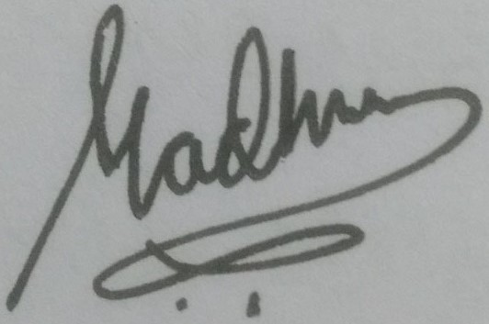 17-12-2021

2.Om Gaydhane

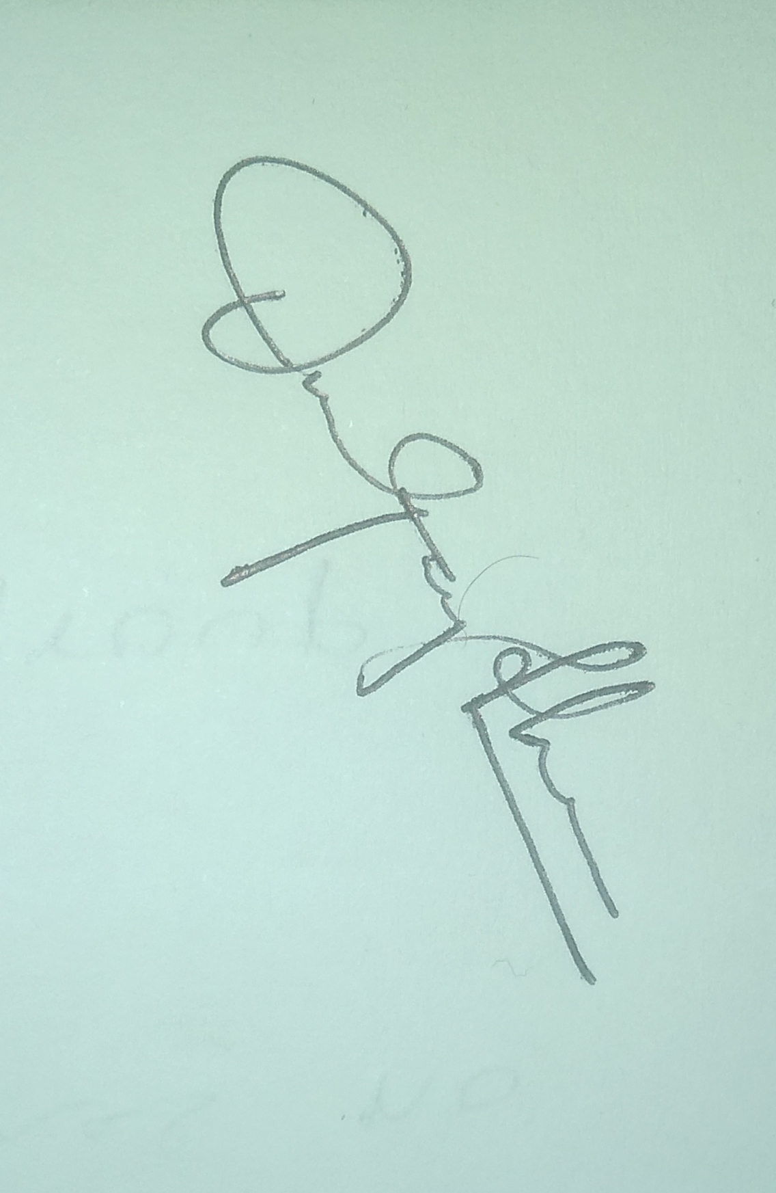17-12-2021

3. Manav Pahilwani

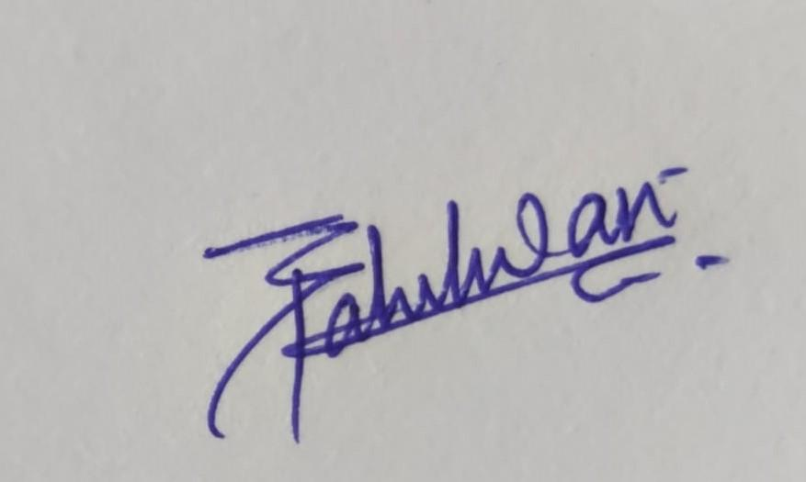17-12-2021

4. Akshat Tiwari

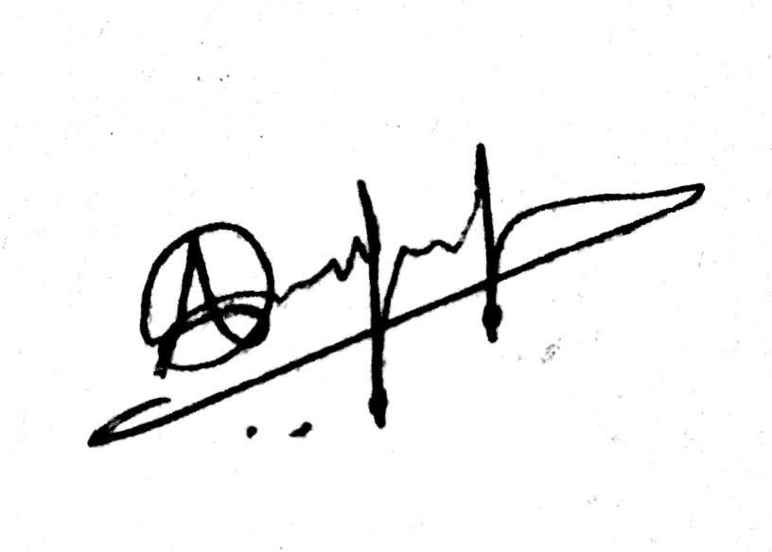17-12-2021

(Name & Signature of Students with Date)

**Acknowledgement**

We are thankful to our college Vivekanand Education Society’s Institute of Technology for considering our project and extending help at all stages needed during our work of collecting information regarding the project.

It gives us immense pleasure to express our deep and sincere gratitude to our Guide, Dr. M. Vijayalakshmi and Mr. Ajinkya Valanjoo for her kind help and valuable advice during the development of the project synopsis and for her guidance and suggestions.

We are deeply indebted to our Principal Dr. J.M. Nair and Vice-Principal Dr. M. Vijayalakshmi for giving us this valuable opportunity to do this project.

We express our hearty thanks to them for their assistance without which it would have been difficult in finishing this project synopsis and project review successfully.

We convey our deep sense of gratitude to all teaching and non-teaching staff for their constant encouragement, support, and selfless help throughout the project work. It is a great pleasure to acknowledge the help and suggestion, which we received from the Department of Artificial Intelligence and Data Science.

Table of Contents

Pg No

**1. Introduction**

1.1. Introduction 1

1.2. Problem Statement 1

1.3. Objectives 1

**2. Literature Survey**

2.1 Literature/Techniques studies 2

**3. Analysis and Design**

3.1 Analysis of the system 3

3.2 Proposed Solutions 3

3.3 Design of the proposed system 4

**4. Results and Discussion** 5

**5. Conclusion and Future Work** 6

**References** 6

**1. Introduction**

**1.1 Introduction :-**

Akimal is based on the popular game, Akinator. It is a program engine that guesses and matches real or imaginary characters based on the answers to questions, a kind of artificial intelligence that uses databases.

**1.2 Problem Statement :-**

Build a game that uses Artificial Intelligence or Machine Learning.

**1.3 Objective :-**

The main aim is to develop a fun and interactive game which is fascinating in its own ways. An addictive game with near to precise results which It’s able to login to the human mind to figure out which animal they are thinking of. . It provides an attractive environment where you can answer a sequence of questions and get the conclusion after a few questions.

**2. Literature Survey**

**2.1 Literature/Techniques studied**

* Decision Tree
* Decision Tree Algorithms

1. ID3 (Iterative Dichotomiser 3)
2. C4.5 (successor of ID3)
3. CART (Classification And Regression Tree)
4. Chi-square automatic interaction detection (CHAID). Performs multi-level splits when computing classification trees.
5. MARS: extends decision trees to handle numerical data better.

**3. Analysis and Design**

**3.1 Analysis of the system**

For the storage and use of knowledge in Akimal is making system and knowledge representation, a set of procedures required to enter data gathered from memory and keep them in working order.

Procedures operating of the knowledge are divided into the following classes:

a.) Updating knowledge.

b.) Classification of knowledge.

c.) Output of knowledge.

Akimal has a database of animals and questions with their answers.

**3.2 Proposed Solutions**

Decision tree learning algorithms will be used in capturing knowledge. The main task performed in these systems is using inductive methods to the given values of attributes of an unknown object to determine appropriate classification according to decision tree rules. Decision trees classify instances by traverse from root node to leaf node. We start from the root node of the decision tree, testing the attribute specified by this node, then moving down the tree branch according to the attribute value in the given set. This process is repeated at the sub-tree level.

**3.3** **Design of the proposed system**

Decision tree is commonly used for gaining information for the purpose of decision-making. Decision tree starts with a root node on which it is for users to take actions. From this node, users split each node recursively according to the decision tree learning algorithm. The final result is a decision tree in which each branch represents a possible scenario of decision and its outcome.

Decision trees consist of three types of nodes which are,

• **Decision node**: Often represented by squares showing decisions that can be made. Lines emanating from a square show all distinct options available at a node.

• **Chance node**: Often represented by circles showing chance outcomes. Chance outcomes are events that can occur but are outside the ability of the decision maker to control.

• **Terminal node**: Often represented by triangles or by lines having no further decision nodes or chance nodes. Terminal nodes depict the final outcomes of the decision making process.

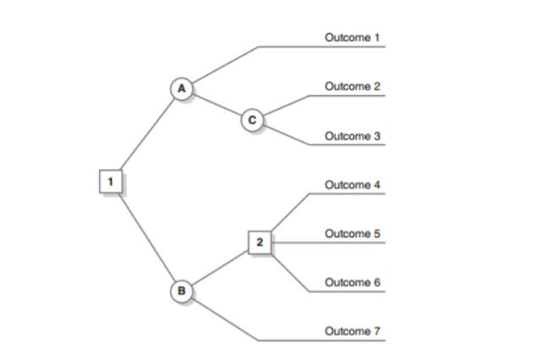

**4. Result and Discussion**

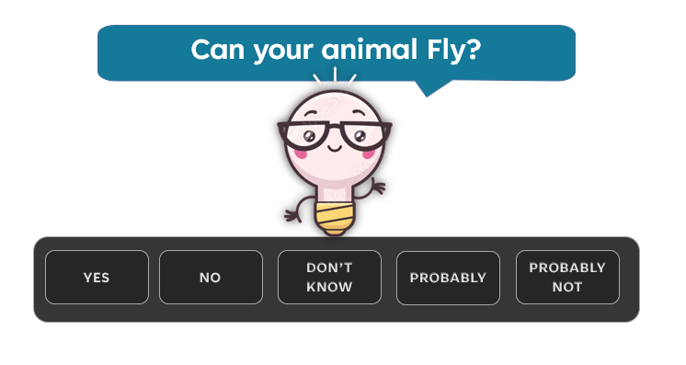

**[This is not the final game interface]**

.

**5. Conclusion and Future Work**

Akimal is a game inspired by Akinator. The player has to think of an animal and answer yes/no questions. Akinator handles uncertainty, as “probably”, “probably not” and “I don’t know” are other possible answers. Using each answer, the program determines the best question to ask next and eventually gives a guess as to who the player is thinking of. It is a very interesting Artificial Intelligence Program that combines elements from decision trees and binary trees, as well as probabilistic methods and machine learning.

We have a complete roadmap of all the concepts we have to work in which we have to study and design our akimal.

Future Work

* Implementation of decision tree model
* Learning and implementing database management
* Connect the model to the database
* Creating a prototype
* Bug fixing
* Creating a GUI

References :-

<https://intelligenceartificiellesi.wordpress.com/2012/12/03/exemple-dun-systeme-expert-akinator/>

<https://en.wikipedia.org/wiki/Decision_tree>

<https://en.wikipedia.org/wiki/Decision_tree_learning>